CS5363-Summer25-Exam 3
Name: Scott Weeden Total Points: 20
R #: R12041454
Note: Please ensure your answers are concise and directly address the questions.
The following are TRUE or FALSE questions. Write TRUE or FALSE by the statements. (6*1= 6 pts)
- A risk in project risk management can be an opportunity or threat to a project.
TRUE
- A contingency reserve is included in the project budget.

- Stakeholder analysis is used to understand who the stakeholders are and what their roles entail.
TRUE
- Good project metrics should be subjective, cost effective and based on intuition rather than being objective.
FALSE
- Leavitt’s model states that people, technology, task, and organizational structure are independent of one another.
FALSE
- The normative-reeducation approach for organizational change focuses on changing social norms and core values of a group.
FALSE
Answer the following short answer questions
- Describe difference between verification and validation in quality assurance. (2pts)
Quality assurance is process oriented, so verification ensures standards are being followed while validation ensures that standards are being met

I.E. The quality assurance process for a manufacturer in ABC’s Bill of Material requires that process standards are being followed:
A.) Each manufacturer’s POC, Legal, and Engineering contacts are on file and updated each 6 months
and that the manufacturer facilities meet standards:
B.) A manufacturer’s facility is ISO-***** compliant

Verification = process standards are being followed (Recently updated
Validation = business standards are being met

- Describe affiliative leadership style. ( 2pts)
Affiliative leadership style focuses more on personal relationships and human talent, rather than project schedules, costs, or milestones. Such a leader places importance on the personal relationships and talent, loyalty, dedication, but risks leaving team members feeling rudderless.

Case study:
- Suppose XYZ company project team is preparing the postmortem report, but several key metrics are missing or inconsistent across sources, leading to conflicting interpretations among the project team members. Apply the project risk identification framework below
to identify and understand the risk sources and the impacts. Assign an owner to the risk and describe a strategy for managing the risk. (5 pts)
Close project -> Unknown-known -> Internal -> Process -> Quality
Assign to Database Administrator (since the risk is Internal)
Negative Risk: Quality Assurance (continual improvement) for Project Management Lifecycle (medium impact)
Positive Risk: Opportunity to standardize and verify key metrics are consistently measured at close of each project (past and going forward)
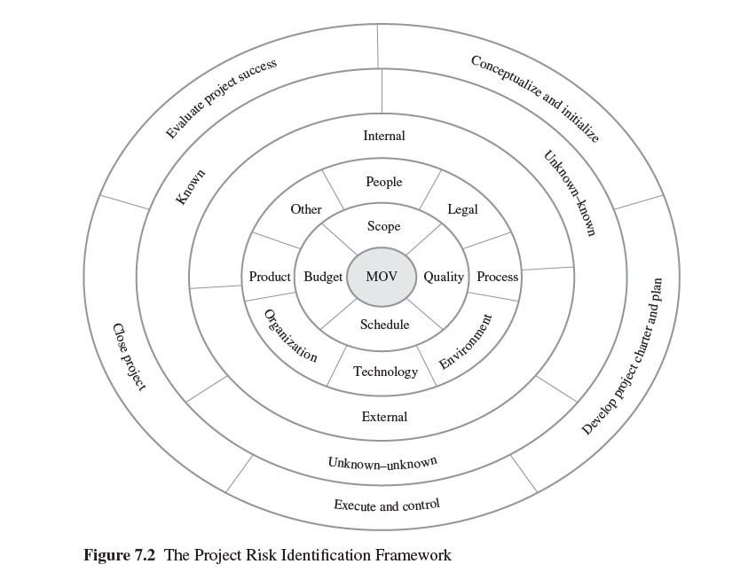

The following shows the planned value, actual value, and earned value for each task of the XYZ company project planned for 2 months. Answer the following questions.
Project Period | Task | Planned Value | Actual Value | Earned Value
1 month | 1 | $1,000 | $2,000 | $1,000
 | 2 | $3,000 | $3,000 | $1,000
 | 3 | $2,000 | $2,000 | $2,000
 | 4 | $1,000 | $1,000
 | 5 | $3,000
 | Totals | $10,000.00 | $8,000.00 | $4,000.00
2 month | 1 | $3,000 | $3,000 | $1,000
 | 2 | $1,000 | $1,000 | $1,000
 | 3 | $2,000 | $2,000 | $1,000
 | 4 | $2,000 | $2,000 | $1,000
 | 5 | $2,000
 | Totals | $20,000.00 | $16,000.00 | $8,000.00
- What is the Budget at completion (BAC) of the project? (1 pt)
BAC = Sum(PV) = $10,000 + $10,000 = $20,000

- What is the estimate at completion (EAC) considering just CPI at the end of first month? What does it mean about the project? (2pts)
EAC = BAC – ( AV – EV) / CPI
CPI = $4,000 / $8,000 = 0.5 < 1 (over budget)
20,000 – (8,000 – 4,000) / 0.5 = 16,000 (The project is 6,000 over budget)

- What is “To Complete Performance Index (TCPI)” of the current budget at the end of second month? What does it mean about the project? (2pts)
Project EV lacks 12,000 behind PV.
Project is 12,000 behind schedule and is 4,000 over budget.
TCPI = 16,000/20,000 (Less than one means that performance target not being met)

